1. Create an AuroraDB Engine based RDS Database.

2. Create 2 Read Replicas in different availability zones for better infrastructure availability.

1. Create an AuroraDB Engine based RDS Database.

RDS > DATABASE >CREATE DATABASE

* Choose a database creation method  > standard create
* Engine options > Engine type > Aurora (MySQL Compatible)
* Engine Version > default
* Templates > Dev/Test
* DB cluster identifie > mycluster
* Credentials Settings > Master username(admin)
* Credentials management > self managed (Mydb2024)
* Cluster storage configuration > Configuration options >Aurora Standard
* Instance configuration > DB instance class >Burstable classes (includes t classes)

Db,t3.medium

* Multi-AZ deployment > Don't create an Aurora Replica ( as per task I will create after creating cluster)
* Connectivity > no instance
* VPC > default
* DB subnet group > default
* Public access > NO
* Sg > allow mysql/arrora from any where
* Availability Zone > us-east-1a
* RDS Proxy > no
* Monitoring > no
* Reset all default and create

Created AuroraDB cluster with only Writer instance

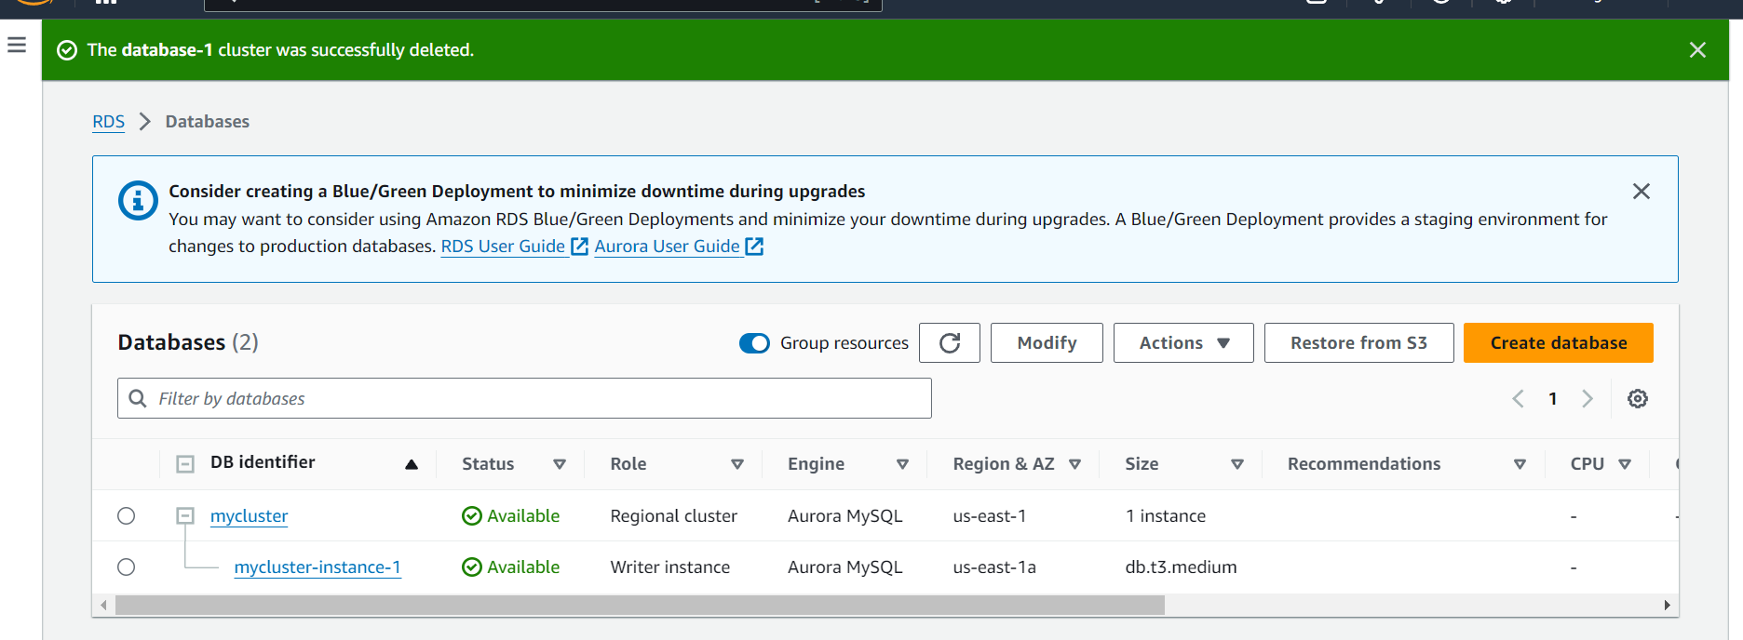

 2. Create 2 Read Replicas in different availability zones for better infrastructure availability.

* Select above cluster > actions > add reader
* Settings >Aurora replica source > select my cluster
* DB instance identifier > reader-1 and reader-1

## Instance configuration > Burstable classes (includes t classes) db.t3.medium

## AWS Region > Destination Region > same default region

## Connectivity > no public

## Availability Zone > us-east-1b and us-east-1c

## Reader01 and Reader02 are created in differs AZ.

